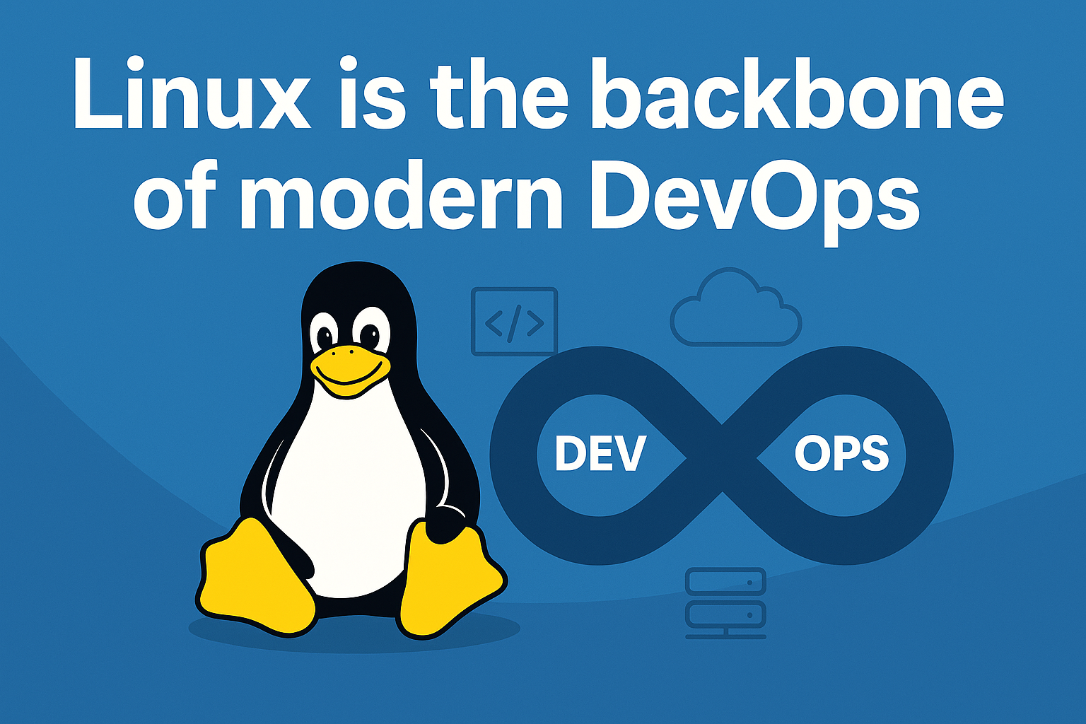

In the world of DevOps, tools and cloud platforms are constantly evolving — but one thing remains constant: Linux.

🐧 **\*\*What is Linux? \*\***

Linux is an open-source operating system used in everything from servers and smartphones to embedded devices and containers. It's fast, secure, and built for automation — making it the ideal choice for DevOps.

```

**Linux is known for its rock-solid stability**

```

**\*\*Mature Kernel: \*\***

The Linux kernel, the core of the operating system, is highly mature and well-maintained, with a long history of stability and performance.

**🔧**Why is Linux So Important in DevOps? \*\***

"Linux is the backbone of modern DevOps."

Learning Linux means gaining control over the systems where your:

Code runs

Infrastructure lives

Pipelines execute

**\*\*Here’s why it's so critical: \*\***

Most cloud servers run Linux (AWS EC2, GCP, Azure)

DevOps tools like Docker, Kubernetes, Jenkins, Ansible, and Terraform are designed for Linux

Scripting and automation are easy with Bash and Linux CLI

Security and user management are easier to control

📚 **\*\*What to Learn in Linux for DevOps? \*\***

To be effective in DevOps, start with these key areas:

Basic Linux commands (ls, cd, cat, grep, etc.)

File & directory permissions (chmod, chown)

Users & groups

Package managers (apt, yum)

Service management with systemctl

Shell scripting

Cron jobs

SSH and key-based access

process management (ps, top, htop, kill, nice, renice, pgrep, pstree)

Logs and monitoring (/var/log, journalctl)

Networking basics (ping, curl, netstat)

🛠️ **\*\*How Linux Powers DevOps\*\***

```

DevOps Area Role of Linux

CI/CD Pipelines Jenkins agents on Linux servers

Containers Docker images are Linux-based

IaC Tools Ansible, Terraform run on Linux nodes

Monitoring Prometheus, Grafana, Nagios on Linux

Cloud Deployments AWS/GCP/Azure default to Linux VMs

```

🧠 **Final Thoughts**

Mastering Linux isn't just a skill — it's a DevOps superpower.

Whether you're automating deployments, troubleshooting servers, or scaling in the cloud, Linux gives you the foundation to build, deploy, and innovate confidently.

✅ New to Linux? Start with the command line.

✅ Already using it? Dive into scripting, services, and logs.